Medinformer – Diarrhoea

DIARRHOEA

Has someone ever told you to just “let diarrhoea work itself out” and not stop it? Some people prefer to not suppress diarrhoea, as they consider it part of our natural defence against intestinal pathogens. It has, however been shown that pathogens trigger diarrhoea and exploit the condition simply to facilitate transmission to others. ^{1C}

When is a runny tummy actually diarrhoea?
It is normal to experience a loose stool or two every now and then. When a person passes unusually loose or watery stools at least three times in a 24-hour period, it is defined as diarrhoea. ^{2S}

South Africans, on average and of all ages, have 1 to 2 incidences of diarrhoea every year. Studies found that households in which children between 5 and 15 years old were part of the family, experienced significantly more episodes of diarrhoea in a year. ^{3A,C} Children below 3 years of age are reported to have on average 3 episodes of diarrhoea a year. ^{2T}

When a person has diarrhoea, they may have other symptoms that accompany the loose stools, which could include: ^{4A}
- nausea (feeling sick)
- vomiting
- fever
- headache
- bloating and flatulence
- abdominal cramps and pains
- loss of appetite
- weakness
- dehydration

Of these symptoms, one of the most deadly, but an easy one to prevent or treat, is dehydration. ^{2A}

What could cause diarrhoea?
Diarrhoea happens when not enough water is removed from your stool, or too much fluid is secreted into the stool, making it loose. ^{4B}

There are a number of reasons why you could experience diarrhoea, some cause only short-lived diarrhoea (acute diarrhoea), and others may cause diarrhoea on a more ongoing basis. ^{4B}

SHORT-TERM ^{4C} |  | LONG-TERM ^{4D}
Infections (called gastroenteritis) by: | Lifestyle: | Chronic diseases: | Medicines:
Viruses, like the rota-virus or noro-virus | Change in diet | Inflammatory or irritable bowel disease, diverticulitis | Antibiotics
Bacteria, often from food, such as E. coli or Salmonella | Ingredients in food, like artificial sweeteners | Food intolerances, such as lactose intolerance or malabsorption – e.g. after bowel surgery | Laxatives, if too many are taken
Parasites, generally from water, such as giardia | Stress | Encopresis / chronic constipation — where diarrhoea overflows around impacted stool stuck in the bowel | Cancer treatment like chemotherapy, or radiotherapy involving the abdomen or pelvis
 | Drinking too much alcohol | Conditions that lower the immunity, such as HIV, cancer, organ transplant.

When it is best to get medical assistance
Some signs that could indicate that the diarrhoea may need medical attention include: ^{5A}
- The diarrhoea is particularly frequent or severe
- There is blood in your or your child's stool
- Persistent vomiting
- A severe or continuous bowel ache
- Weight loss
- Signs of dehydration, such as drowsiness, passing urine infrequently, and feeling lightheaded or dizzy
- Stool is dark or black – this may be a sign of bleeding inside your stomach

Preventing diarrhoea
As diarrhoea is often caused by infection by a virus, bacteria or parasite, the best way to prevent diarrhoea would be to pay close attention to everyday hygiene practices around you and your family. ^{5B}


- Wash your hands thoroughly with soap and warm water after going to the toilet and before eating or preparing food. Check that all members of the family, including children, do the same.
- Clean the toilet, including the handle and the seat, with disinfectant after each bout of diarrhoea
- Avoid sharing towels, cutlery, or utensils with other household members ^{5C}

While you are travelling, take special care to practise good food and water hygiene, such as
avoiding potentially unsafe tap water and undercooked food. ^{5C}

Treatment of diarrhoea

For both adults and children, the first treatment recommended during a bout of diarrhoea is oral rehydration solution (ORS). As dehydration can be very dangerous, treating or preventing dehydration is critical. ^{2A. 6A,B}

An interesting fact is that mild or moderate dehydration can be successfully treated with oral rehydration solution in 9 out 10 cases, without the need for an intravenous drip. However, less than half of South Africans use ORS during a bout of diarrhoea ^{2A, 3B}
To treat the diarrhoea itself, treatment for adults and children are different. Children should be assessed by a healthcare professional to determine the cause of the diarrhoea and prescribed the most appropriate treatment to stop the diarrhoea. Adults may use an antidiarrhoeal medicine, such as loperamide.

Some antidiarrhoeal products are available in easy-to-use formats, that makes taking medicine when you are not feeling well due to diarrhoea easier. One of these formats is a melt tablet – a convenient dissolvable tablet. When the tablet is placed on the tongue, it melts within seconds and can easily be swallowed. No water is needed, and it is especially suitable for those with swallowing difficulties. ⁷

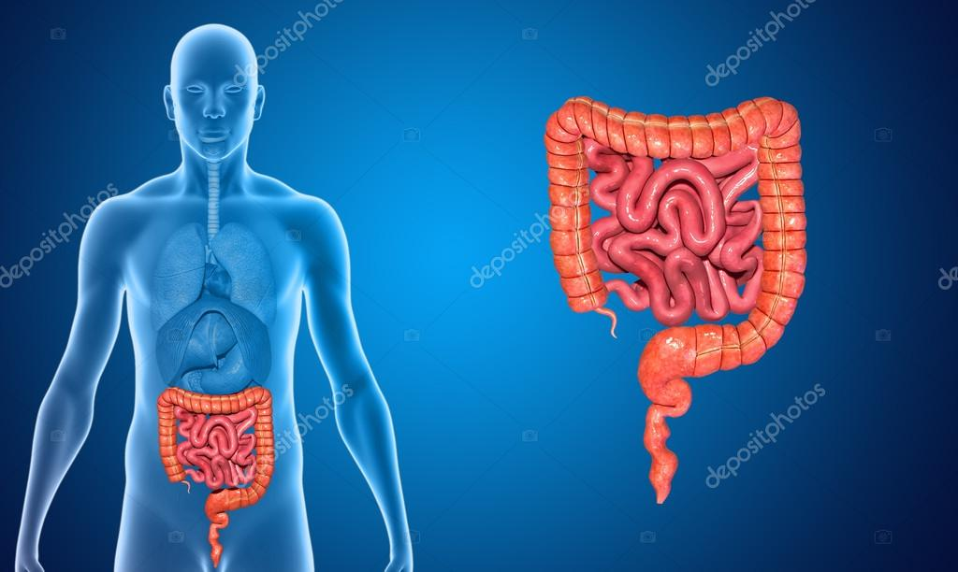
Loperamide targets diarrhoea in 3 ways ^{8A,9A}
3
1
2

- It controls muscle contractions to normalise movement of the gut, allowing more time for water and salts to be absorbed.
- Changes how much water and electrolytes is secreted and absorbed in the bowel, resulting in a firmer stool passing into the rectum.
- Helps prevent faecal incontinence, by tightening the anal sphincter (a round muscle that closes the rectum).

Loperamide gets to work within 1 hour and has shown that it significantly reduces the number of watery stools on day 1 & 2 of use vs people that take no antidiarrhoeal medication. ^{9,10,11}
In a study amongst people with diarrhoea, the persons that did not take loperamide, experienced unformed stools for more than 30 hours, while those that took loperamide only had watery stools for 12.5 hours. ¹²

Speak to your healthcare professional about the convenient and effective solutions for the control and treatment of diarrhoea and dehydration from Johnson & Johnson today.

References:

- Lääveri T, et al. Systematic review of loperamide: No proof of antibiotics being superior to loperamide in treatment of mild/moderate travellers' diarrhoea. Travel Medicine and Infectious Disease, 2016;14:299- 312.
- The treatment of Diarrhoea – A manual for physicians and other senior health workers. World Health Organisation. Available at https://apps.who.int/iris/bitstream/handle/10665/43209/9241593180.pdf;sequence=1. Accessed 11/04/2020.
- Johnstone SL, Page NA, Thomas J, et al. Diarrhoeal diseases in Soweto, South Africa, 2020: a cross-sectional community survey. BMC Public Health, 2021;21:1431.
- Diarrhoea. HealthDirect [Online]. June 2021. Available from https://www.healthdirect.gov.au/diarrhoea. Accessed 01/03/2022.
- Diarrhoea. NHS inform [Online] 23 Nov 2021. Available from https://www.nhsinform.scot/illnesses-and-conditions/stomach-liver-and-gastrointestinal-tract/diarrhoea. Accessed 01/03/2022.
- Standard Treatment Guidelines and Essential Medicines List for South Africa, 2019 edition. Available from http://www.health.gov.za/index.php/standard-treatmentguidelines-and-essential-medicines-list/category/286-hospital-level-adults#. Accessed 2020/07/07.
- Data on File – REF-01419: Ipsos Report on Vermox claims, Dec 2020.
- Baker DE. Loperamide: A Pharmacological review. Reviews in Gastroenterological Disorders 2007;7(3):S11-S18.
- Regnard C, et al. Therapeutic reviews: Loperamide. Journal of Pain and Symptom Management, 2011;42(2):319-323.
- Amery W. et al. A multicentre double-blind study in acute diarrhoea comparing loperamide (R 18553) with two common antidiarrhoeal agents and a placebo. Current Therapeutic Research 1975; 17(3):263-270.
- Van Loon FP, et al. Double blind trial of loperamide for treating acute watery diarrhoea in expatriates in Bangladesh. Gut 1989;30(4):492-5.
- Hanuaer SB, et al. Randomized, double-blind, placebo-controlled clinical trial of loperamide plus simethicone versus loperamide alone and simethicone alone in the treatment of acute diarrhea with gas-related abdominal discomfort. Current Medical Research and Opinion. 2007; 23(5):1033-1043.

ZA-IM-2200002

